**Exercise 3: Assertions in JUnit   
Scenario:**You need to use different assertions in JUnit to validate your test results.   
**Step 1:**

Created a AssertionTest.java

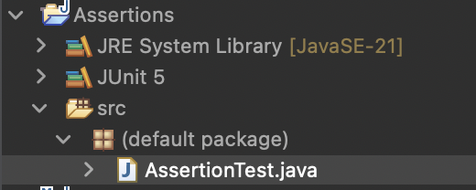

**Step 2:**

Solution Code:

import org.junit.jupiter.api.Test;

import static org.junit.jupiter.api.Assertions.*;

public class AssertionTest {

*@Test*

public void TestAssertions()

{

*assertEquals*(5,2+3);

*assertTrue*(5>3);

*assertFalse*(5<3);

*assertNull*(null);

*assertNotNull*(new Object());

}

}

After running AssertionTest,java below is the output: